Representative Player Agreement

As a Player selected for an Otago Hockey Representative team, I understand I am in a privileged position, which attracts certain responsibilities. During my time as an Otago Representative Player, from the signing of this Agreement until I return home from Tournament,
I AGREE to adhere to the following
Otago Hockey Representative Player Agreement:
- That I will priorities Otago trainings, games and tournaments, attending all trainings in a timely fashion unless otherwise agreed with the Head Coach;
- That I will train at my individual best to ensure I create an environment that conducive to producing excellence;
- That I will work to increase my fitness level outside of Otago trainings to meet fitness standards set by the Head Coach;
- That I will act in a professional manner at all times, including, but not limited to;
  - Punctuality, language, physical standards, training attire and respect of coaches, managers, other players and team mates and OHA staff;
  - Respecting umpires and officials at both national and local competitions, avoiding personal penalties and disciplinary measures;
  - A high standard of behavior, and following the directions of the coaches and managers;
- That I will follow all Drug Free Sport NZ rules and regulations and attend a seminar if required;
- That I will not criticize Otago Hockey, Hockey New Zealand, their staff, officials or coaches in social media or any public forum;
- That I will ensure I am financial with my local club, school and/or Association;
- That I will pay all fees and costs required of me by the Due Dates set out below, unless I have made special arrangements with the Manager which are approved by Otago Hockey;
- That I am responsible for all my own costs until payment is received from a sponsor. If sponsorship money is not received by Otago Hockey by the Due Date, I am responsible for the full amount;
- I will travel with the team, unless I have special arrangements approved by Otago Hockey. These must be requested to the Manager by the Due Date below;
- That I will purchase any items of Required Team Apparel that I do not already possess;
- That I will promptly return all Otago Hockey uniforms and equipment to the Manager within 2 weeks of tournament finishing, I agree to pay for any uniform items lost while in my possession.
- Seniors
That I will make myself available to my local Association for a minimum of 10 hours of volunteer work within the hockey community. These volunteer hours and the tasks within these hours will be directed by Otago Hockey. I will have completed this work by the Due Date below.
Under 15’s
That I will make myself available to help with the Otago Year 5&6 Development Programme for a minimum of 3 hours. Trainings, umpiring and tournaments. Managers will send information out about dates and times of training and tournaments.
Under 13’s
That I will make myself available to my local Association for a minimum of 3 hours of volunteer work within the hockey community in either umpiring or coaching. These volunteer hours and the tasks within these hours will be directed by Otago Hockey. I will have completed this work by the Due Date below.

Volunteer work I will complete:
Contact person:
Contact email:
DUE DATES
Deposit/ Frist installment Team Dependent Friday 2nd August
Special Travel Arrangement must be requested Friday 16th August
Second Installment Team Dependent Friday 23rd August
Sponsorship Money Due Team Dependent Date if applicable
Final Installment Remainder of cost Friday 13th September
Volunteer Work must be completed July 2020
REQUIRED TEAM APPAREL*
Otago Apparel $TBC depends on team Item
(which players get to keep)
IN SIGNING THIS AGREEMENT I UNDERSTAND THAT Failure to uphold any part of this Agreement MAY RESULT IN MY REMOVAL FROM THE REPRESENTATIVE TEAM WITHOUT REFUND. I UNDERSTAND THAT BEHAVIOUR DEEMED UNACCEPTABLE BY THE MANAGER AT ANY TOURNAMENT MAY RESULT IN ME BEING SENT HOME AT MY OWN COST WITHOUT REFUND.
SIGNED: DATE:
Player Signature

SIGNED: DATE:
Guardian Signature (for Players under 18)

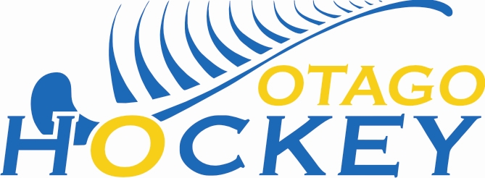
PLAYER MEDICAL INFORMATION FORM

Players Name:____________________________________________________

Address: _________________________________________________________

Date of Birth: _______________ My Phone #: ___________________________

Emergency Contact Person: _________________________________________

Phone #: ________________ __________________ _________________
^{Home} ^{Work} ^{Cell}
Doctors Name: ______________________ Phone : _____________________

Medical Conditions | Information or instructions for emergency actions
Epilepsy YES / NO
Fainting/dizzy spells YES / NO
(or sudden loss of consciousness)
Heart Condition YES / NO
Diabetes YES / NO
Ear Disorder YES / NO
(Including deafness)
Respiratory Disorder YES / NO
(Particularly asthma)
Allergies YES/ NO
(Foods, bites & stings)
Any injuries YES / NO

Other Relevant Medical information

I Authorise the Team Manager to obtain all medical assistance deemed necessary and agree to pay all medical expense incurred.

Signed:________________________________ Date:__________________
^{Athlete Signature}

Signed: _______________________________ Date: ________________ ^{Guardian signature}

